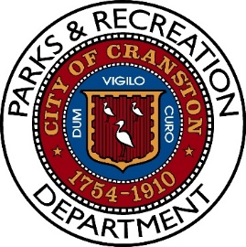
Notice of Meeting
Parks and Recreation Advisory Board Meeting
Monday, March 23rd, 2026, 6:00PM
Pastore Youth Center
155 Gansett Avenue
Cranston, RI 02910

AGENDA

- Roll Call

- Fall/Winter Review – Preventative maintenance plan put in place.

- Equipment Update – Several upgrades since last meeting

- Update on Ongoing Projects

  - What is completed – 13 basketball venues plus other projects, Stadium and West.
  - What is upcoming – Cooney and Wildflower Playgrounds, Speck 2 back online
  - Potential future projects – Dependent on Capital Budget Allocation

- Illegal Garbage Issue – Proactive measures and results.

- Pool Operations and Facilitation plans have begun with a CPO on board.

- Open Dialogue

- Adjourn

